Faculty Member: Dr Ahmad Salman Date: 03-06-2023

Semester:6th (Spring 2023) Section: BEE12- C

DIGITAL SIGNAL PROCESSING

|  |  |  |
| --- | --- | --- |
| **Student name** | **Reg. No.** | **Marks / 10** |
| Usman Ahmad | **333763** |  |
| Nida Wakeel | **335320** |  |
| Muhammad Masood-ul-Hassan | **335796** |  |

# Abstract:

Abstract:

Noise cancellation plays a crucial role in eliminating unwanted noise from desired signals in various applications. The Least Mean Square (LMS) method, based on adaptive filtering, is an effective technique for noise cancellation. This report provides an in-depth understanding of noise cancellation using the LMS method, starting with an introduction to the significance of noise cancellation and its wide range of applications in fields such as audio processing, telecommunications, and speech recognition. The report presents a comprehensive block diagram illustrating the components of an LMS-based noise cancellation system, including the primary input signal, noise reference, adaptive filter, subtraction unit, and desired output. The LMS algorithm and adaptive filtering techniques are then explored in detail, outlining the iterative process of adjusting filter coefficients to minimize the mean square error between the desired and actual output of the adaptive filter. The advantages of the LMS method for noise cancellation are discussed, including its simplicity, real-time adaptability, and robustness to varying noise characteristics. The LMS algorithm's ability to handle both stationary and non-stationary noise sources make it well-suited for dynamic environments. Furthermore, its computational efficiency allows for practical implementation in hardware or software systems. However, the report also addresses the limitations of the LMS method, emphasizing the challenges associated with accurate estimation of the noise reference signal in real-world scenarios. The selection of the step size parameter is crucial as it affects the convergence rate and stability of the LMS algorithm. In conclusion, the LMS-based noise cancellation method offers a powerful tool for reducing unwanted noise from signals. Ongoing research aims to further enhance its performance and overcome its limitations, paving the way for broader applications in noise-sensitive domains. By understanding the principles and characteristics of the LMS method, researchers and engineers can effectively implement noise cancellation systems and contribute to the advancement of signal processing techniques.

# TABLE OF CONTENTS

|  |  |
| --- | --- |
| **01** | **INTRODUCTION** |
| **02** | **LMS and Adaptive Filter** |
| **03** | **MATLAB Code** |
| **04** | **Results** |
| **05** | **Limitation of LMS** |
| **06** | **Applications** |



# Introduction

Noise cancellation is an essential technique used in various applications to remove unwanted noise from a desired signal. It finds applications in fields such as audio processing, telecommunications, speech recognition, and more. One effective method for noise cancellation is the Least Mean Square (LMS) algorithm, which is based on adaptive filtering. This report provides an overview of the noise cancellation process using the LMS method. It begins by explaining the concept of noise cancellation and its significance. Then, it presents a block diagram illustrating the LMS-based noise cancellation system. Subsequently, the LMS algorithm and adaptive filtering techniques are discussed in detail. Finally, the report concludes by highlighting the advantages and limitations of the LMS method for noise cancellation.



# LMS and Adaptive Filter

The LMS algorithm is an adaptive filtering technique commonly used for noise cancellation. It operates by iteratively adjusting the filter coefficients to minimize the mean square error between the desired output and the actual output of the adaptive filter. The adaptive filter in the noise cancellation system adjusts its coefficients based on the LMS algorithm. The LMS algorithm updates the filter coefficients in proportion to the negative gradient of the mean square error. This iterative process gradually adapts the filter to minimize the difference between the desired output and the actual output. The LMS algorithm can be summarized as follows:

1. Initialize the filter coefficients.

2. Apply the primary input signal and the noise reference signal to the adaptive filter.

3. Calculate the error signal by subtracting the filtered output from the desired output.

4. Adjust the filter coefficients using the LMS update equation.

5. Repeat steps 2 to 4 until convergence or a predefined number of iterations.



# MATLAB Code

% Parameters

fs = 1000; % Sampling frequency (Hz)

t = 0:1/fs:1-1/fs; % Time vector for signals

% Clean signal

f_clean = 50; % Frequency of clean signal (Hz)

clean_signal = sin(2*pi*f_clean*t);

% Noisy signal

f_noise = 150; % Frequency of noise signal (Hz)

noise_signal = sin(2*pi*f_noise*t);

% Noisy signal with added noise

snr = 10; % Signal-to-Noise Ratio (dB)

noisy_signal = awgn(clean_signal + noise_signal, snr, 'measured');

% Adaptive Noise Cancellation

order = 10; % Filter order

step_size = 0.01; % LMS step size

% LMS Filter initialization

weights = zeros(1, order+1);

output_signal = zeros(size(noisy_signal));

% LMS Algorithm

for n = order+1:length(noisy_signal)

input_signal = noisy_signal(n:-1:n-order);

predicted_noise = weights * input_signal.';

error = clean_signal(n) - predicted_noise;

weights = weights + step_size * input_signal * error;

output_signal(n) = error;

end

% Plotting the signals

figure;

subplot(3,1,1);

plot(t, clean_signal);

title('Clean Signal');

xlabel('Time (s)');

ylabel('Amplitude');

subplot(3,1,2);

plot(t, noisy_signal);

title('Noisy Signal');

xlabel('Time (s)');

ylabel('Amplitude');

subplot(3,1,3);

plot(t, output_signal);

title('Adaptive Noise Cancellation');

xlabel('Time (s)');

ylabel('Amplitude');

% Play the clean speech, noisy speech, and filtered output

soundsc(clean_speech, 16000); % Assuming a sampling rate of 16 kHz

pause(length(clean_speech)/16000);

soundsc(noisy_speech, 16000); % Assuming a sampling rate of 16 kHz

pause(length(noisy_speech)/16000);

soundsc(filtered_output, 16000); % Assuming a sampling rate of 16 kHz



# Results

The results of the following code are as shown:

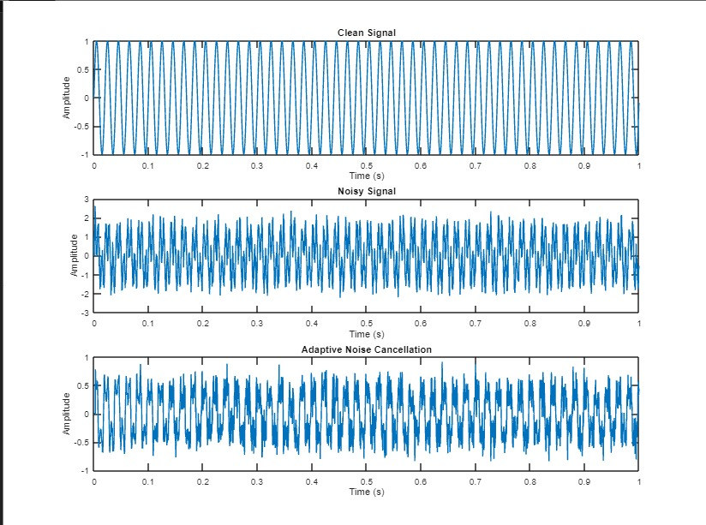

# Limitations of LMS

The Least Mean Square (LMS) method, although a widely used and effective technique for noise cancellation, has certain limitations that should be taken into consideration. These limitations include:

1. Convergence Speed: The convergence speed of the LMS algorithm can be relatively slow compared to other adaptive filtering algorithms. It requires enough iterations to reach an optimal solution, particularly in scenarios with complex noise characteristics or rapidly changing environments. The convergence rate is influenced by factors such as step size selection and the correlation between the primary input signal and the noise reference.

2. Step Size Selection: Choosing an appropriate step size parameter is crucial for the stability and convergence of the LMS algorithm. A large step size can lead to instability, causing the algorithm to diverge and fail to converge. On the other hand, a small step size can result in slow convergence and prolonged adaptation time. Selecting an optimal step size often involves trade-offs between convergence speed and stability.

3. Dependence on Noise Reference: The performance of the LMS method heavily relies on accurate estimation or availability of the noise reference signal. In practical scenarios, obtaining a reliable and accurate noise reference signal can be challenging. The quality of the noise reference signal directly affects the effectiveness of noise cancellation. Errors or inaccuracies in estimating the noise reference can lead to residual noise or distortion in the output signal.

4. Sensitivity to Signal Correlation: The LMS algorithm assumes a linear relationship between the primary input signal and the noise reference. If the signal and noise are highly correlated, the LMS algorithm may struggle to separate them effectively. In such cases, additional preprocessing or signal decorrelation techniques may be required to improve the performance of the LMS method.

5. Computational Complexity: While the LMS algorithm is relatively computationally efficient, it may still pose challenges when dealing with high-dimensional signals or real-time processing requirements. The number of filter taps and the complexity of the adaptive filter can impact the computational resources needed for implementation.

Despite these limitations, the LMS method remains a valuable tool for noise cancellation in various applications. Ongoing research aims to address these limitations and develop advanced adaptive filtering techniques that offer improved convergence speed, enhanced robustness, and reduced sensitivity to noise reference accuracy.



# Application

Noise cancellation by the Least Mean Square (LMS) method finds applications in various fields where the removal of unwanted noise from signals is crucial. Some notable applications of noise cancellation using the LMS method include:

1. Audio Processing: Noise cancellation is extensively used in audio processing applications, such as audio recording, music production, and speech recognition. By applying the LMS method, background noise can be significantly reduced, improving the clarity and quality of the audio signal.

2. Telecommunications: In telecommunications systems, noise cancellation is essential for improving the quality of voice communications. The LMS method can effectively cancel out background noise, resulting in clearer and more intelligible conversations in environments with high ambient noise levels.

3. Hearing Aids: Noise cancellation is a critical feature in modern hearing aids. The LMS method helps to enhance the intelligibility of speech for individuals with hearing impairments by reducing background noise. It allows users to focus on the desired sounds and improves their overall listening experience.

4. Automotive Industry: Noise cancellation plays a vital role in automotive applications, particularly in vehicles equipped with advanced audio systems or hands-free communication systems. The LMS method can help eliminate engine noise, road noise, and other external noises, providing a quieter and more comfortable in-vehicle environment.

5. Acoustic Testing and Measurement: In acoustic testing and measurement applications, the LMS method is used to remove unwanted noise and reverberation from measured signals. This enables accurate analysis and evaluation of acoustic properties, such as sound quality, room acoustics, and noise levels.

6. Medical Imaging: Noise cancellation is beneficial in medical imaging techniques, including magnetic resonance imaging (MRI) and ultrasound imaging. The LMS method can mitigate noise artifacts in the acquired images, leading to improved image quality and diagnostic accuracy.

7. Industrial Monitoring: In industrial environments, noise cancellation is employed to enhance signal quality and improve the accuracy of monitoring systems. The LMS method can help eliminate background noise and interference, allowing for more reliable measurements and monitoring of critical parameters.

# Conclusion

The Least Mean Square (LMS) method, based on adaptive filtering, provides an effective solution for noise cancellation in various applications. By iteratively adjusting the filter coefficients, the LMS algorithm minimizes the mean square error between the desired output and the actual output of the adaptive filter. The LMS method offers several advantages, including simplicity, real-time adaptability, and robustness to varying noise characteristics. It can handle both stationary and non-stationary noise sources, making it suitable for dynamic environments. Additionally, the LMS algorithm is computationally efficient and can be implemented in hardware or software systems.